Career Cruising Directions: www.careercruising.com
Enter hawkeyecc as username
Enter waterloo as password

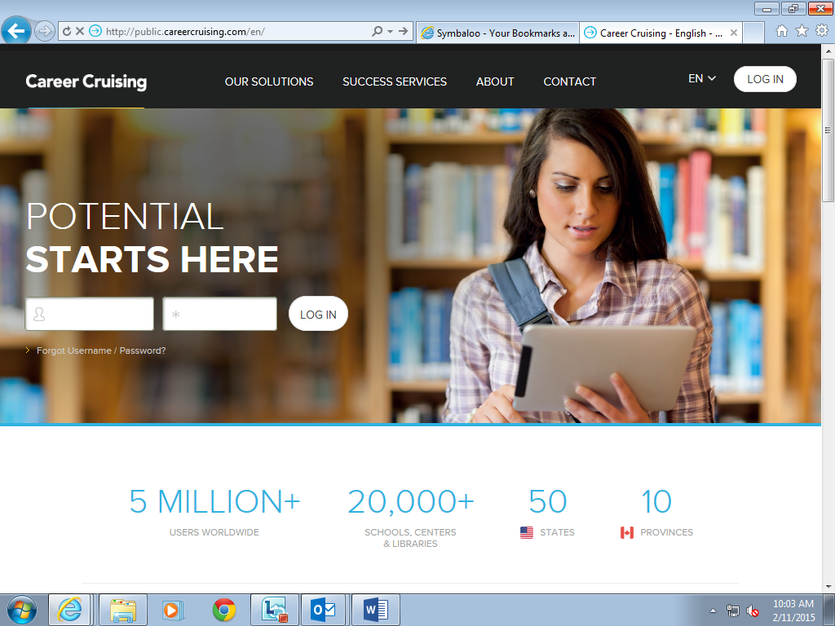
Create an account for yourself. Once you come up with your own unique username and password, you will use it each time you log back in to Career Cruising.

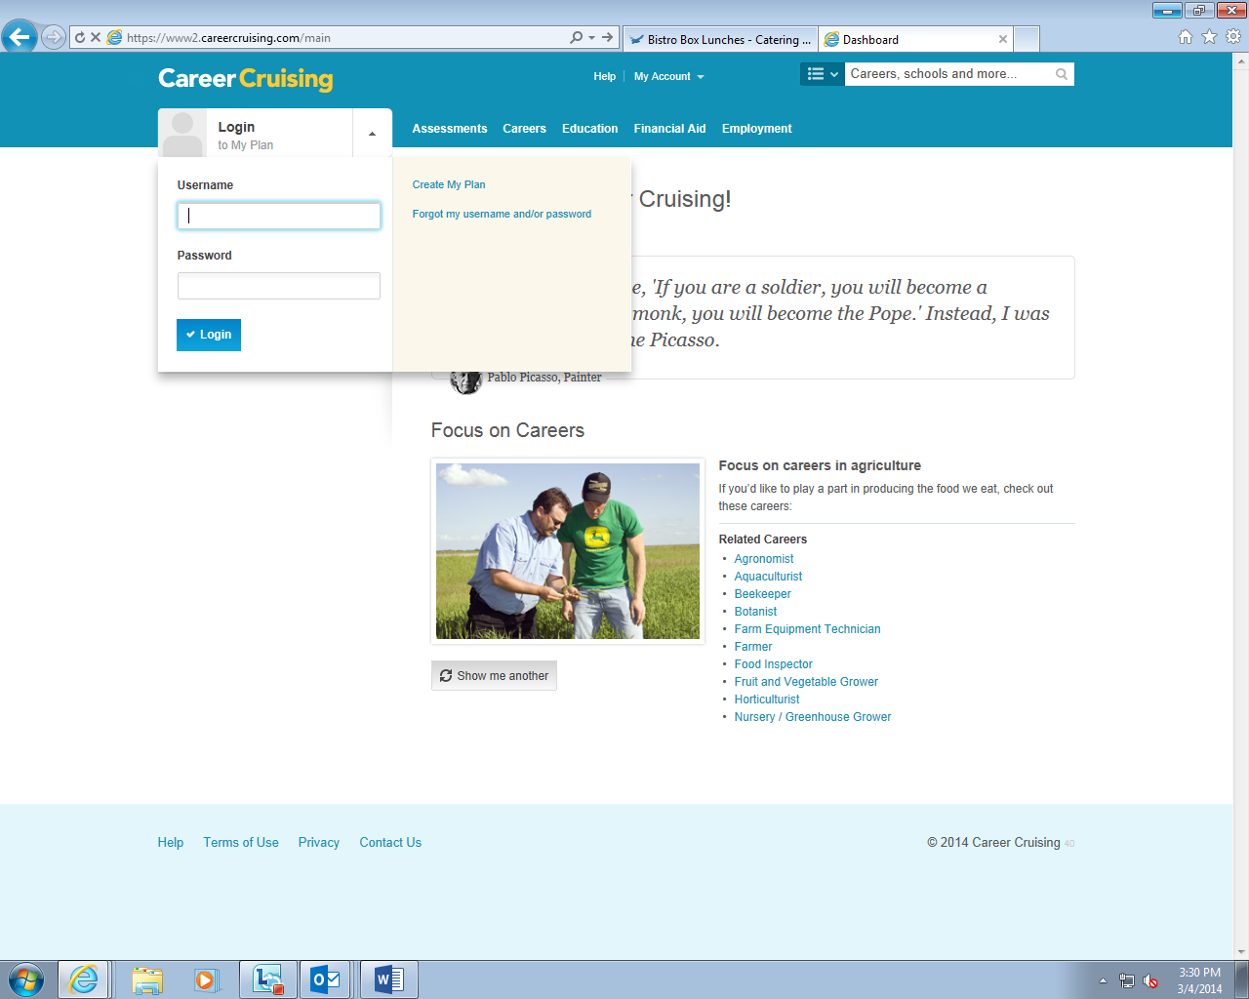

To take an assessment, select “Assessments” at the top of the page.

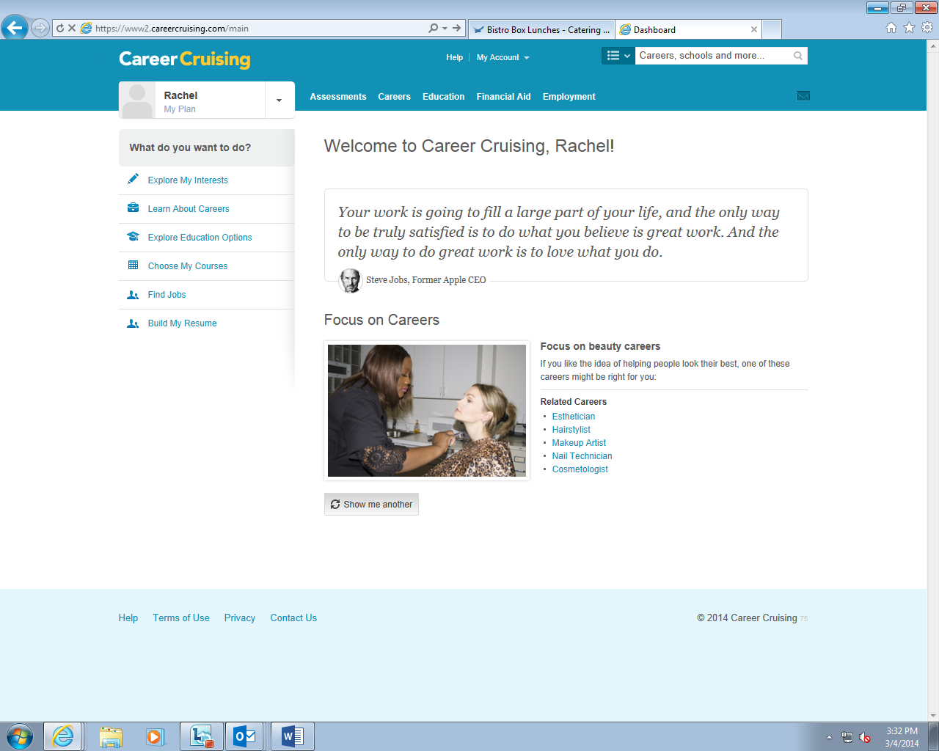

Select “Start Matchmaker”

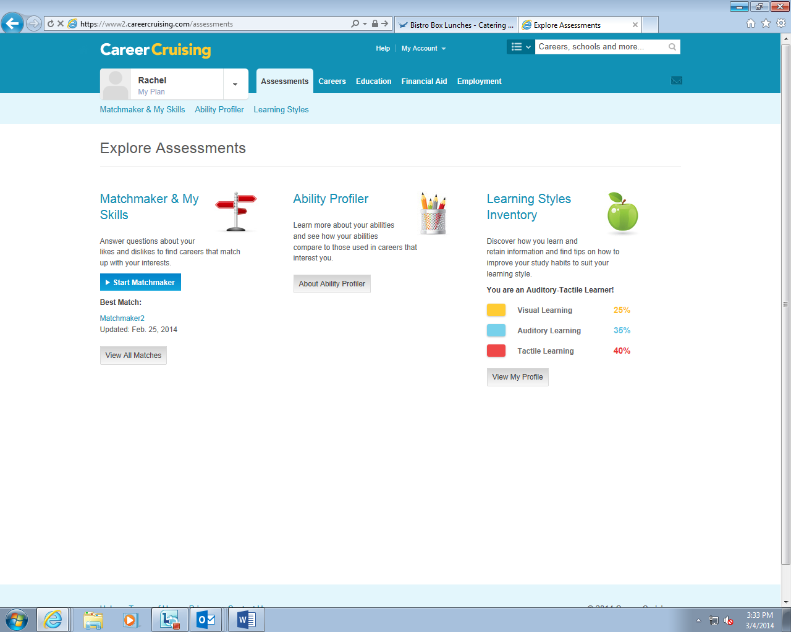

Name your Matchmaker assessment. You can name it whatever you would like; it will save and you will be able to access it at any time.
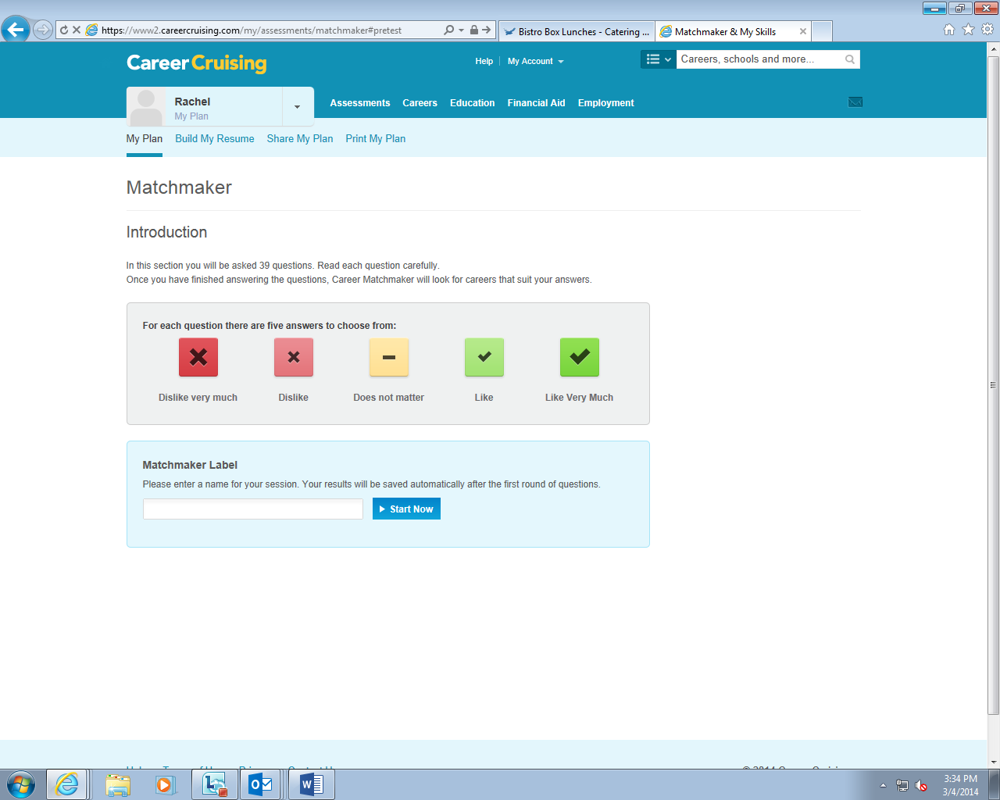

- Begin taking the Matchmaker assessment. There will be a total of 116 Matchmaker questions and 45 skills questions—for best results, ANSWER ALL QUESTIONS. These questions will be grouped; every so often you will come to page like the one shown. Go to the “Improve My Results” section and select “Answer More Questions” to continue.

- Once your assessment is complete, it will bring up results based on the answers you provided. It will show your “Career Cluster Recommendations” and offer suggested occupations.
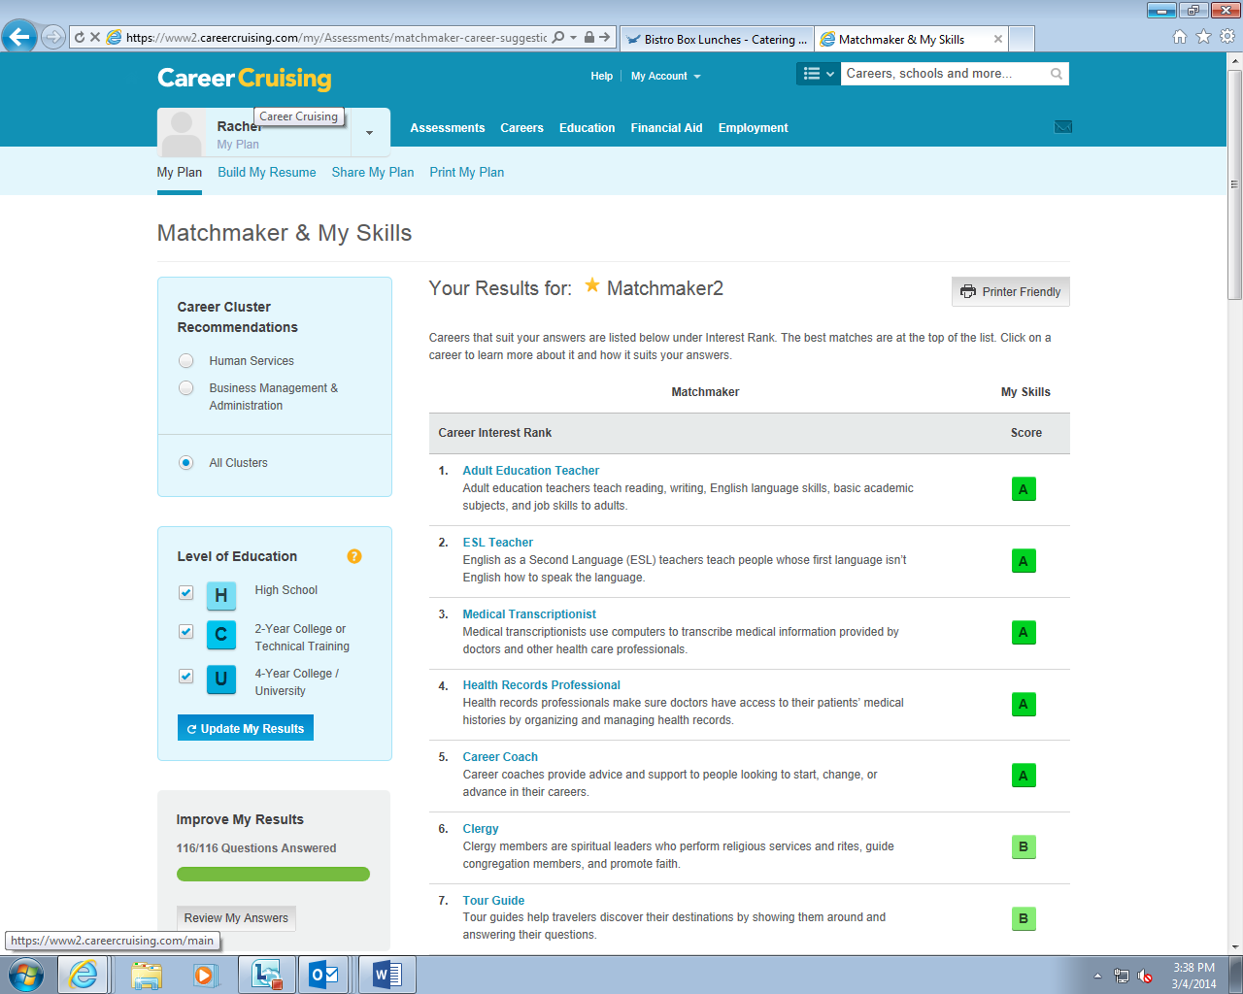

From here, you can begin to explore various occupations. Once you click on an occupation, it will provide specific information about that career. Be sure to review each tab to learn more (At a Glance, Suitable for You, Job Description, Working Conditions, Earnings Education, Sample Career Path, Related Careers, Other Resources).

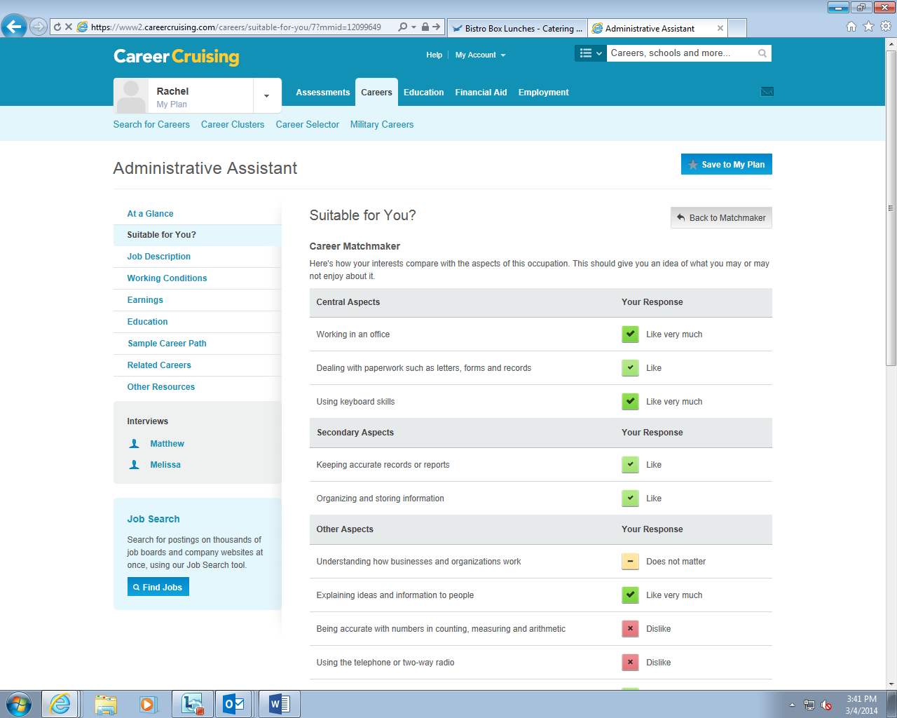

*To return to your assessment page that featured your original career clusters and occupations, click on the “Back to Matchmaker” button.

If an occupation you are interested in does not appear on your list, you can type it into the search bar to learn more.

Contact the Career Services Center to discuss your results and learn more about these careers and occupations.
Bremer Hall Room 102
319-296-4297
careerservices@hawkeyecollege.edu

